Building Mobile Apps Using Xamarin.Forms with .NET Standard

Introduction:

The .NET Standard Library is a formal specification of .NET APIs that are intended to be available on all .NET runtimes. You can understand another way its expanded, Portable Class Library. It is a single library with a uniform API for all .NET Platforms including .NET Core. You just create a single .NET Standard Library and use it from any runtime that supports .NET Standard Platform.

You can refer following table lists all the versions of .NET Standard and the platforms supported

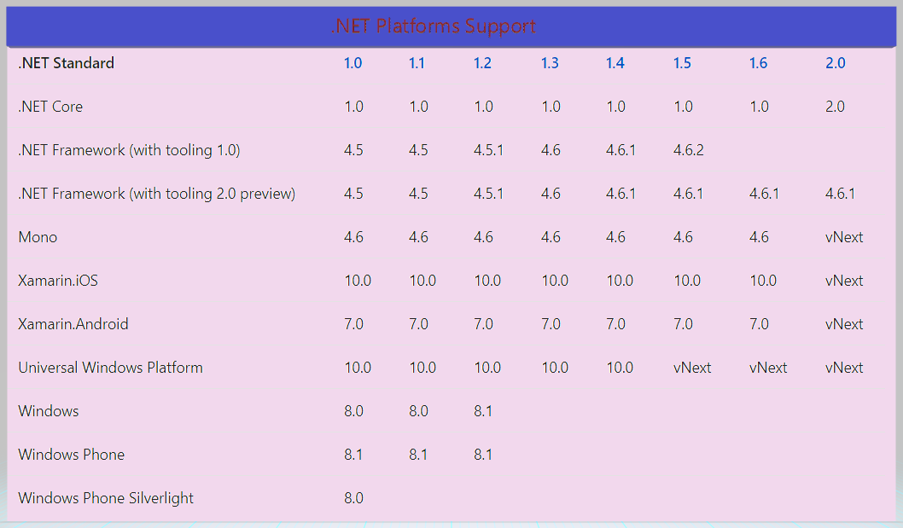

In this article, you will learn how to create mobile cross platform application using Xamarin Forms with .NET Standard libraries and maximize code sharing.

Create New Xamarin Forms:

Let’s start create new Xamarin Forms application, In Windows machine > Go to Run (Windows key +R) > type Devenv.exe for open Visual Studio and select New project from File menu > New Project (ctrl +Shift+N) or click More project template from VS Start screen.

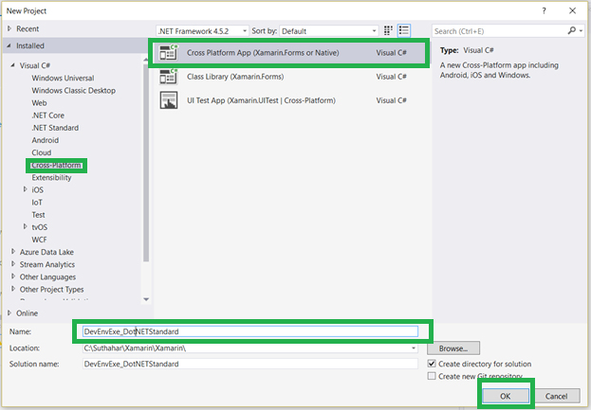

Click on Ok > You will get following screen. Select Blank App > Select Xamarin Forms UI Technology > Select Code sharing as PCL or Share Project and click on Ok

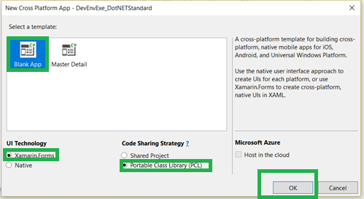

After click on Ok, VS will automatically create PCL,iOS,Android ,UWP projects .

Create .Net Standard Class library

You can follow below steps for create .Net Standard library,

Right Click on solutions > Add new project > Create Class library (.Net Standard) that targets .net Standard and click on Ok

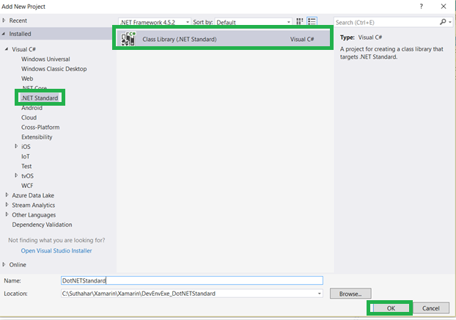

Install Xamarin Forms in .Net Standard library:

The Xamarin.Forms 2.3.5-prerelease will support with .NET Standard. Right Click on .net Standard library > Select on Manage Nuget package

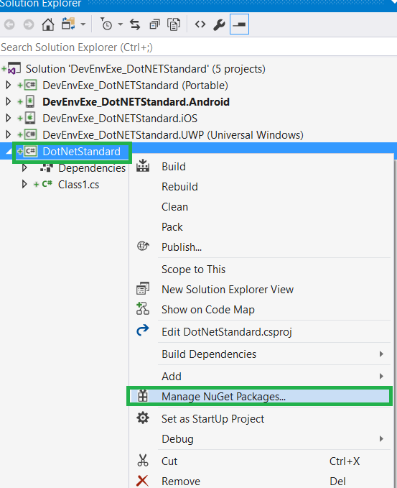

Select on Browse tab > Search text ‘ Xamarin.Forms ‘ > Select Include prerelease and select Xamarin Forms and click on Install

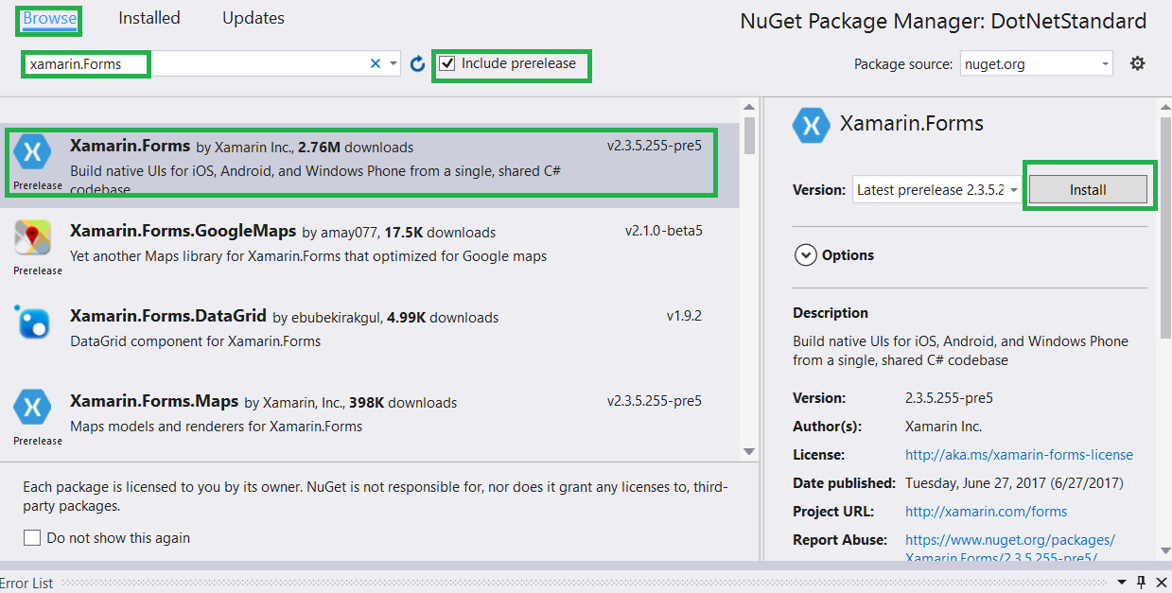

Customize the Application:

You can follow below steps for customize the platform specific project and .net standard library.

**Step 1:** Right Click on .Net Standard library > Click on Add Item > Select Cross -Platform >Forms Blank Content Page Xaml > Provide name as MainPage.xaml

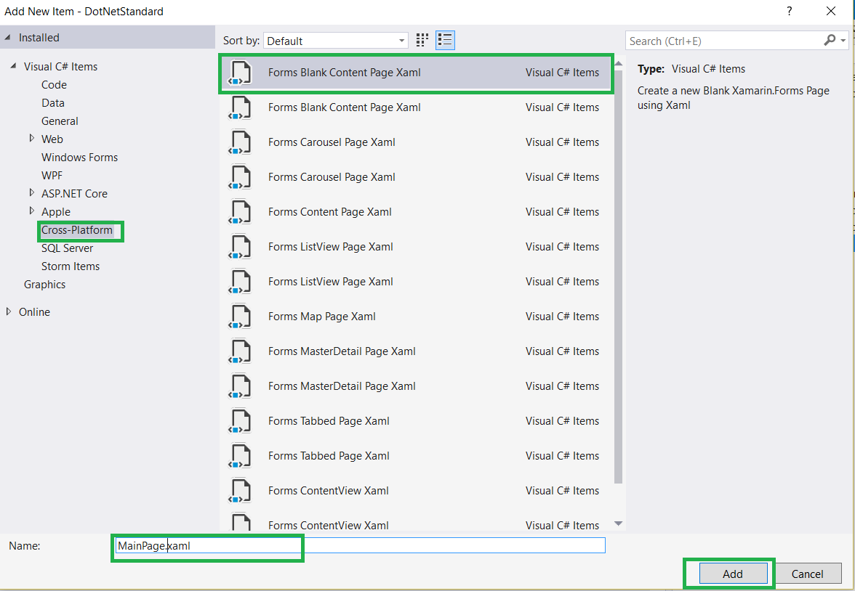

**Step 2:** You can add UI design as per your requirementin **MainPage.xaml .**

1. <?xml version="1.0" encoding="utf-8" ?>
2. <ContentPage xmlns="http://xamarin.com/schemas/2014/forms"
3. xmlns:x="http://schemas.microsoft.com/winfx/2009/xaml"
4. x:Class="DotNetStandard.MainPage">
5. <Label Text="Welcome to Xamarin.Forms Apps with .NET Standard!"
6. VerticalOptions="Center"
7. HorizontalOptions="Center" />
8. </ContentPage>

**Step 3:** Copy App.cs and App.xaml from PCL or Shared project and past into .net Standard library and change the name space from xaml and c# page

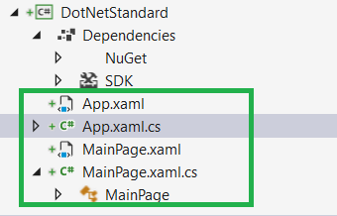

**Step 4:** Remove Shared or PCL Project and Remove PCl project reference from all iOS,Android,UWP project. Now solution look like below

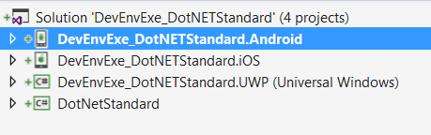

**Step 5:** Add your .Net Standard class library reference to iOS,Android,UWP project.

**Step 6:** Change name space from following project

* In UWP project, updated the name space from mainPage.cs

LoadApplication(new DotNetStandard.App());

* In Android Project , Update the name space from Main Activity

LoadApplication(new DotNetStandard.App());

* In iOS Project , Update the name space from Appdelegate

LoadApplication(new DotNetStandard .App());

Step 6: If you get following error while build the project

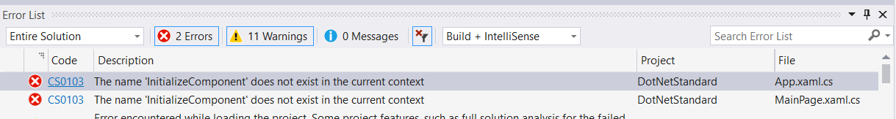

You can follow below for resolution Right Click on Xaml page > Select property and Build Action Should be Embedded Resource

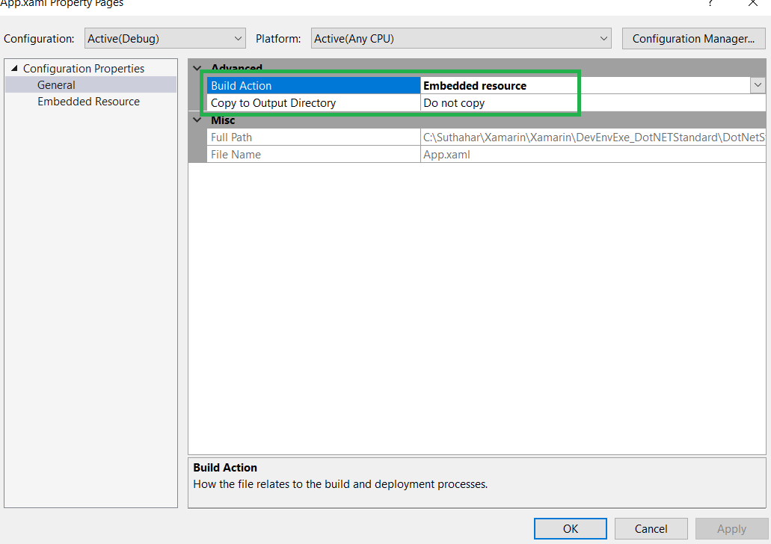

Run the Application:

You can run the application (iOS,Android ,Windows) to all the platform

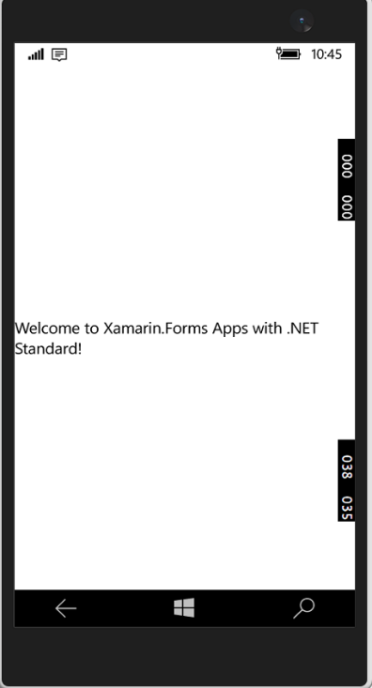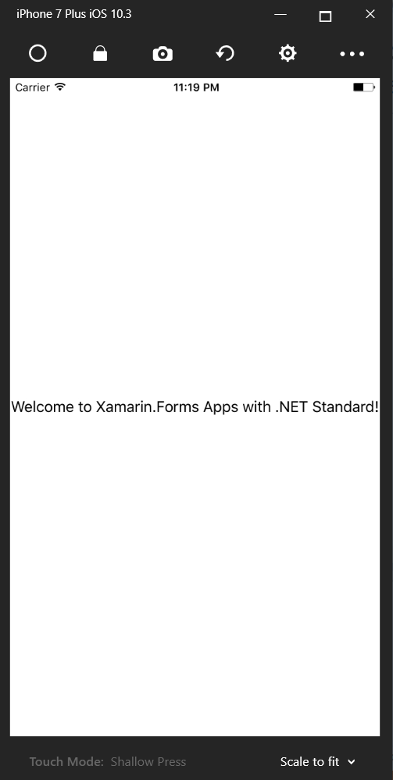 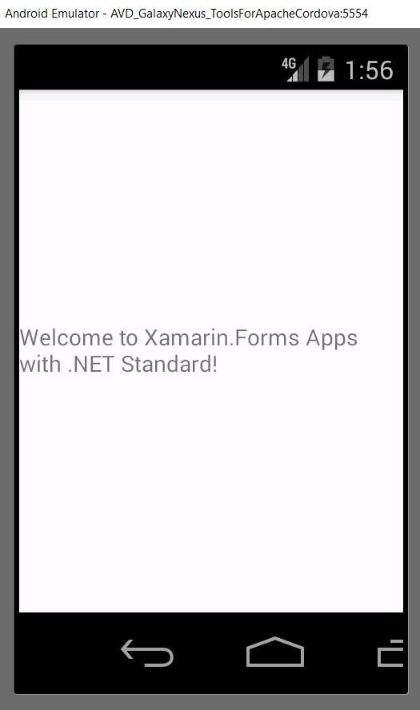

Summary

In this article, you learned how to create mobile cross platform application using Xamarin Forms with .NET Standard libraries.

If you have any questions/ feedback/ issues, please write in the comment box.